**SURAJ SINGH (20210102718), YASH VERMA (04410102718)**

**BTECH CSE**

**MENTOR: Dr. Ram Shringar Rao**

MINOR PROJECT SYNOPSIS



**PROBLEM STATEMENT:-**

To study and predict life expectancy life expectancy for different countries in years

**A BRIEF OVERVIEW OF THE CASE STUDY:-**

Life expectancy refers to the age at which a person is estimated to be alive and is an important determinant of human life in any country. In the pre-modern world, life expectancy was very close to about 30 years, but after the 19th century, life began to increase and doubled. There has been an ongoing debate about how long developed countries have longevity compared to developing or developed countries and as a result to get a clearer picture of this we decided to analyze the Life Expectancy data.

By definition, life expectancy is based on an estimate of the average age that members of a particular population group will be when they die.

Life expectancy depends on several factors, the two most important being gender and birth year. Generally, females have a slightly higher life expectancy than males due to biological differences. Other factors that influence life expectancy include:

* Race and Ethnicity
* Family Medical History
* Risky Lifestyle choices

However, that’s hardly the entire list! As we work our way through the data analysis, we will explore additional hidden factors that influence the life expectancy of an individual.

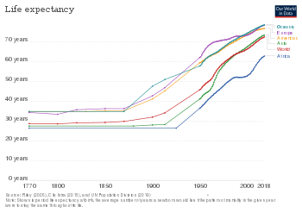

**OBJECTIVE:**

* To predict Life Expectancy in different countries.
* To analyze and observe different life expectancy trend over the world.
* To determine various factors affecting life expectancy in the recent decade.
* To determine the effectiveness of various machine learning algorithms on predicting life expectancy.

**Methodology:**

In this study we have use a dataset consisting of various parameters(Country, Status, Life Expectancy, Adult Mortality, Infant Deaths, Alcohol etc.) and have done our analysis on the given dataset using Regression (Thiel and Ridge, Gradient Boosting) , Clustering and Mixed Model .

**References:**

<https://matplotlib.org/>

<https://numpy.org/>

<https://pandas.pydata.org/>

<https://scikit-learn.org/>